**CS6326 Final Projects – Phase 2 – Happy Dictionary**

Spring 2017

1. Description by Phase1 in following diagrams:

|  |  |
| --- | --- |
| Description: | Check |
| Just like the quiz game which has 4 screens, the main screen, the level choosing screen, question screen, and the score screen | √ |
| Mean screen: maybe 4 or 5 menus, for level choosing and High score | √ |
| In level Screen: Each level has 10 multiple questions, and each question only has one answer. | √ |
| After answered 10 multiple questions, show the score of the test. And save the record to the high score. | √ |
| It is a quick game, so you need to answer it quickly. If you don’t know, quickly flip the phone to pass. | √ |
| The score shows the rank of each user, and time they answered | √ |

Details of the Program:

1. Main Screen: Start the Game, Hight Sore, About Us, and Exit.

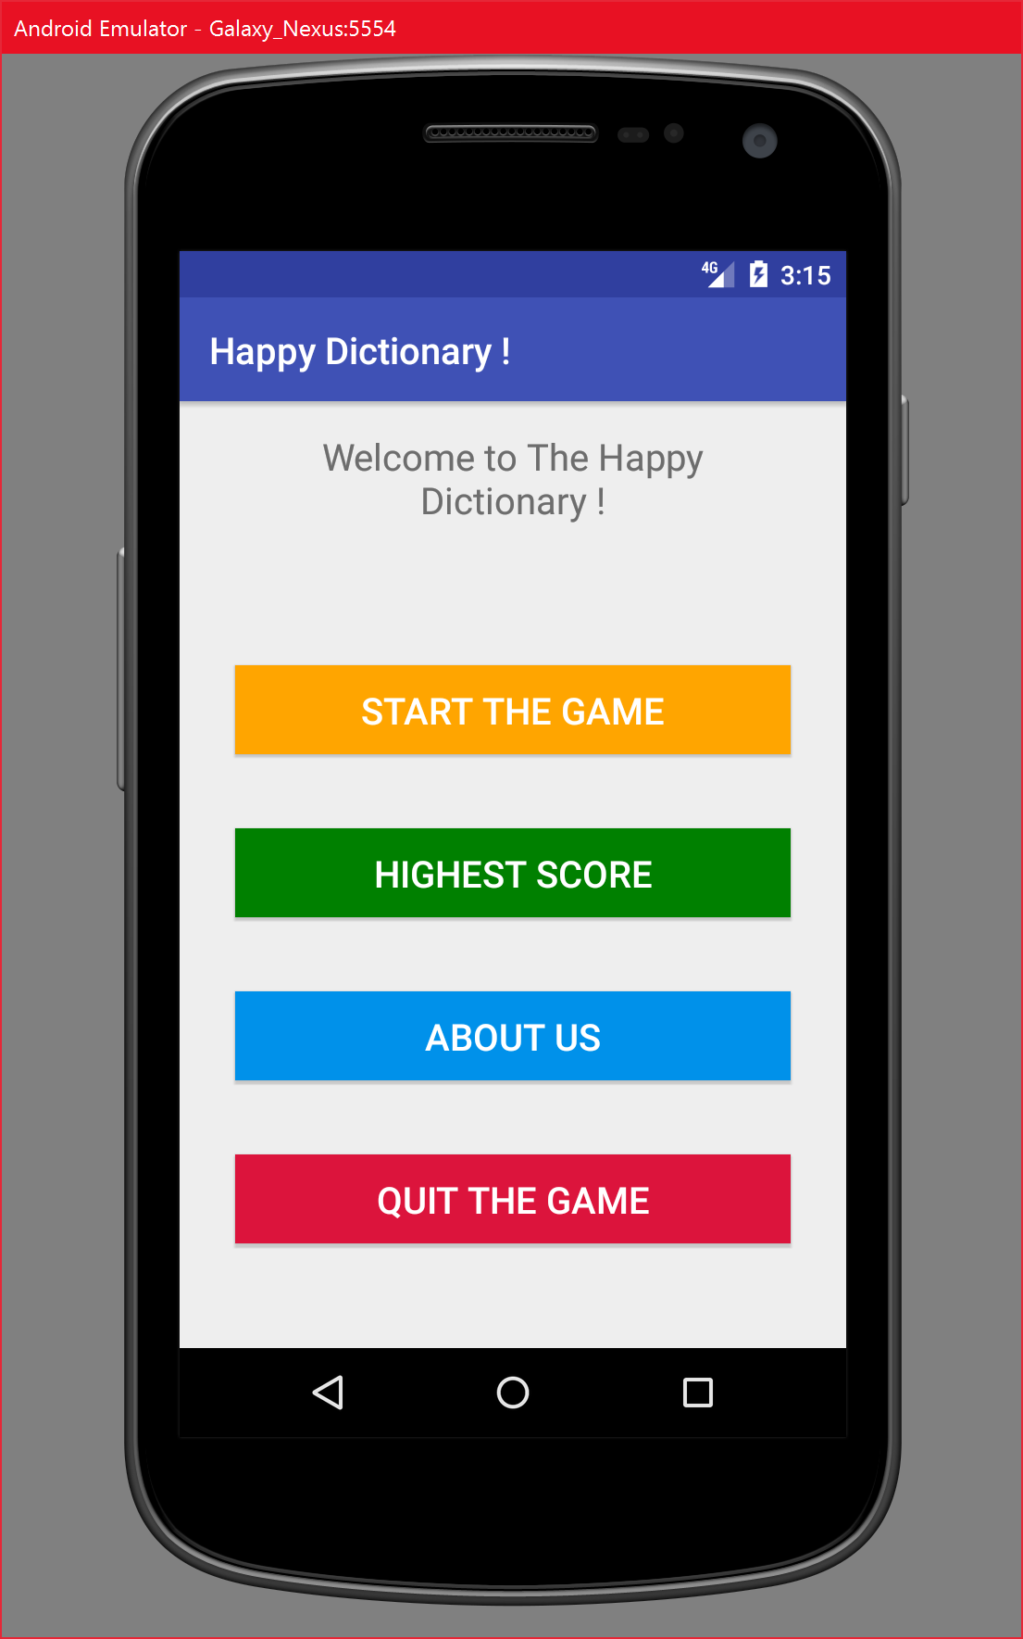

1. Level Choose: Science, History, Economic, Computer, return menu.

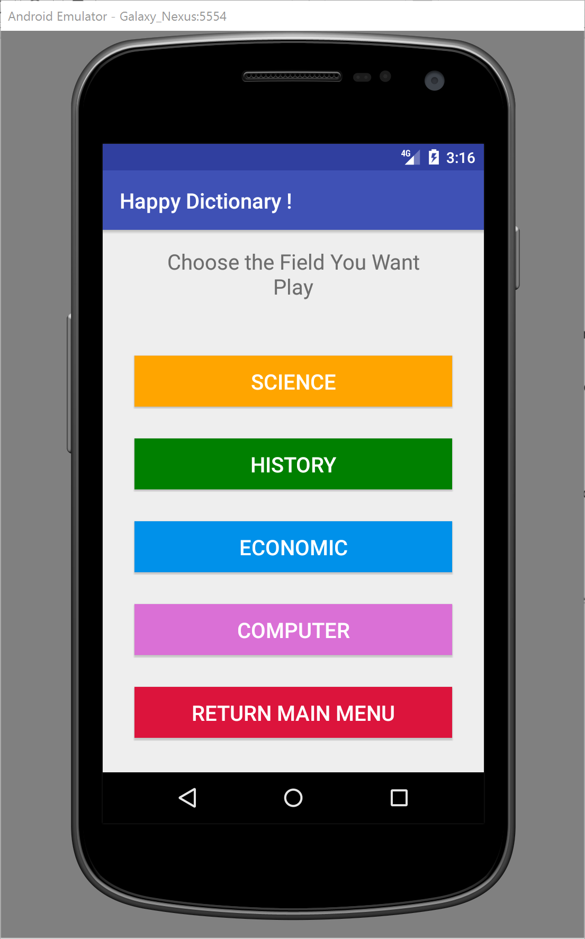

1. High Score: high score, time of high score, clear all the record, return menu using scroll.

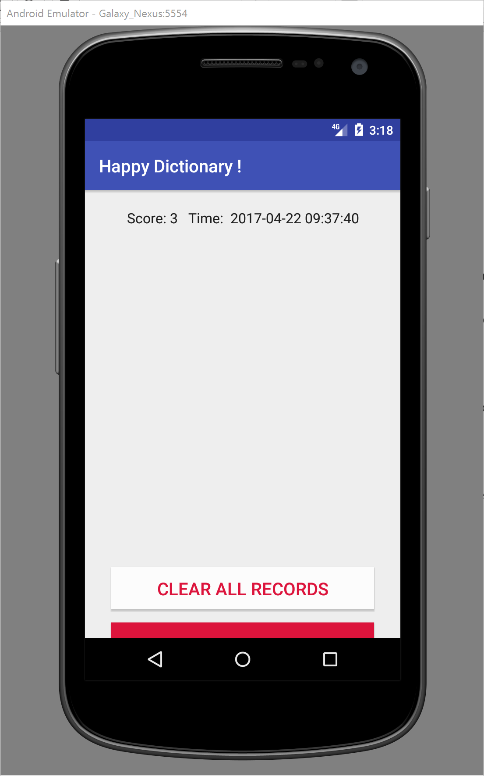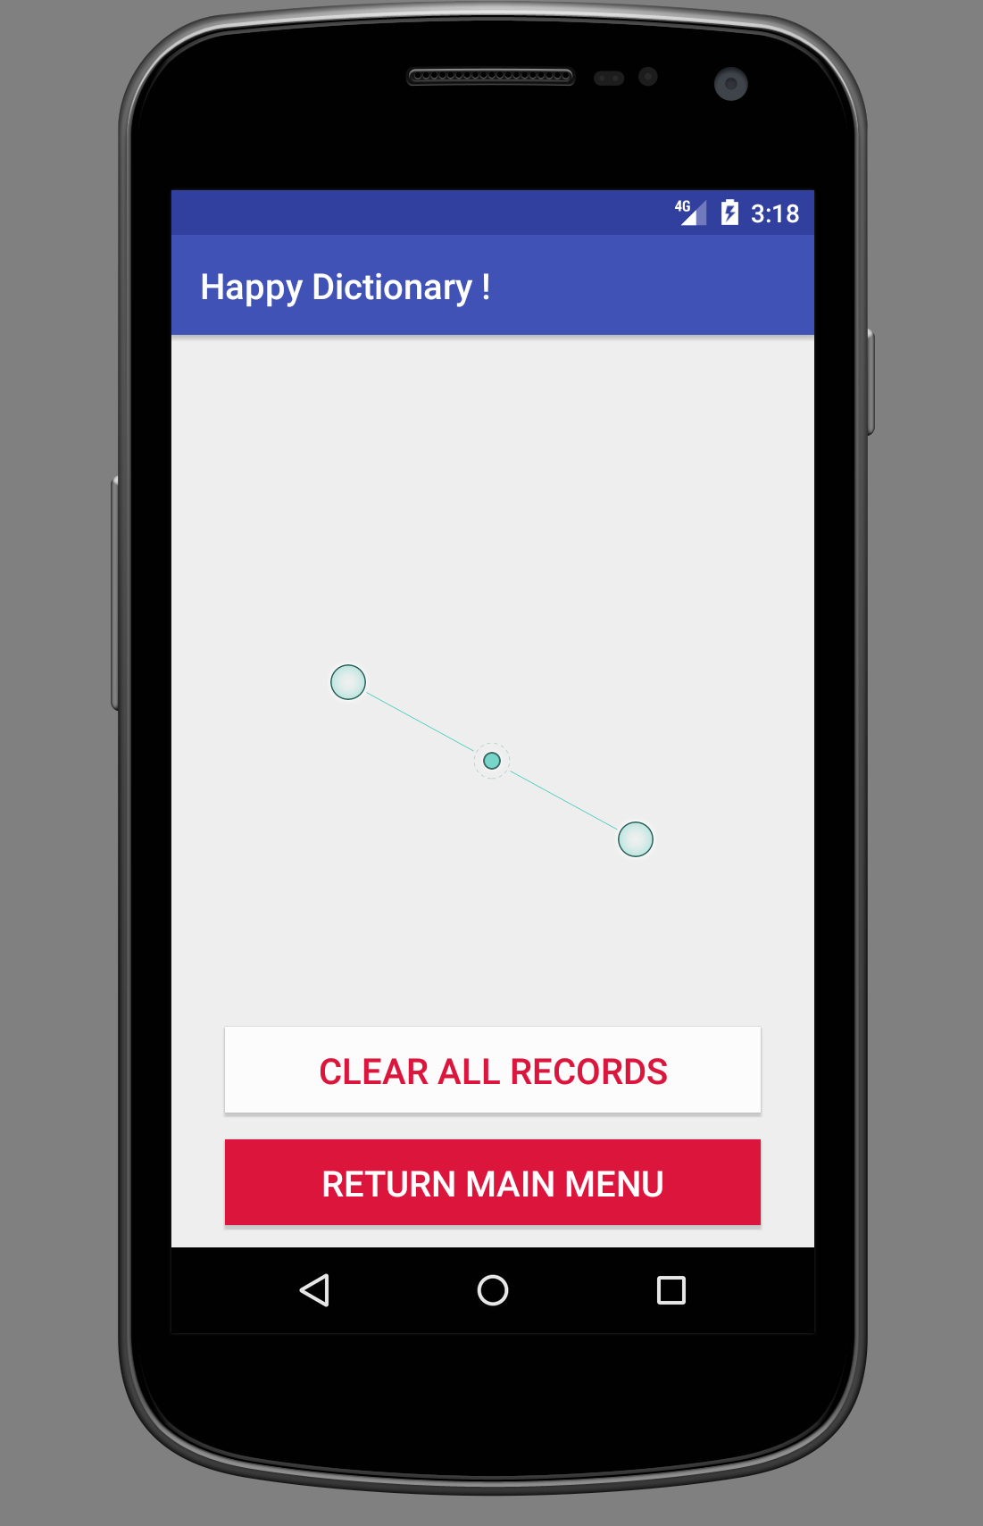

1. About us and Exit

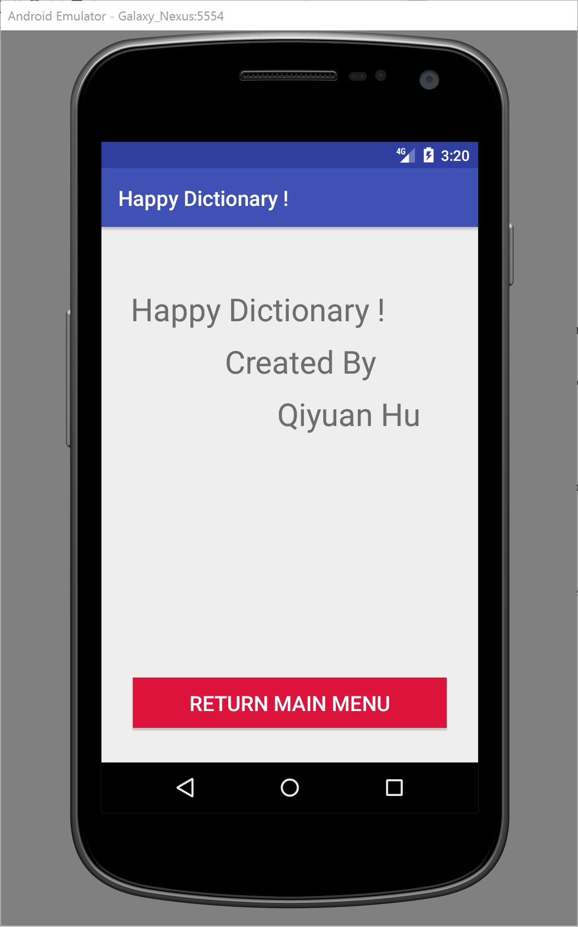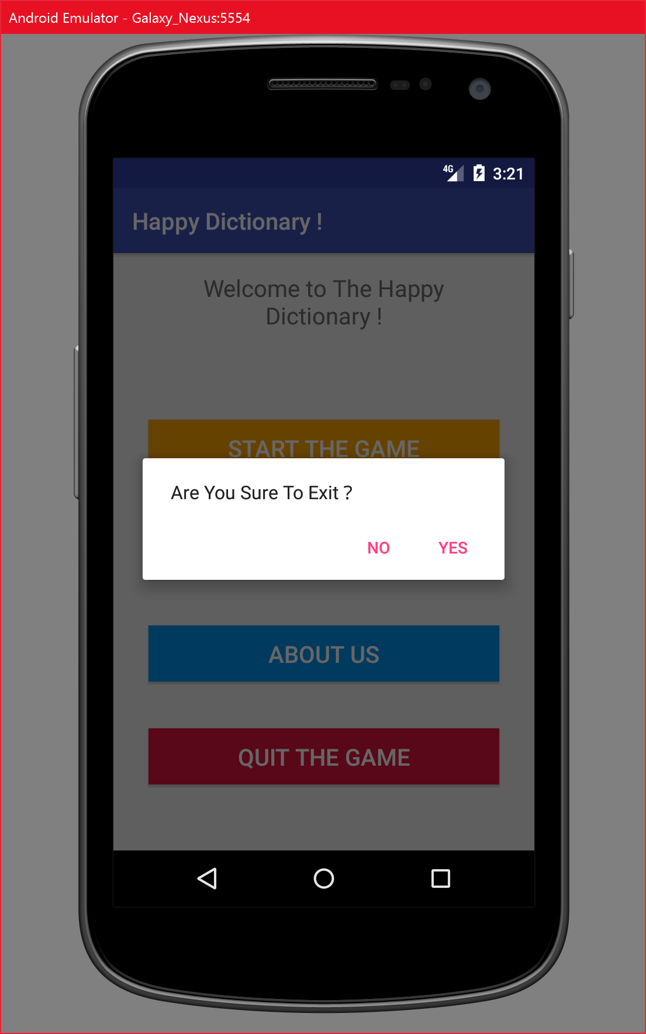

1. Quiz screen:

